**How to Complete Magma Math Assessment(Teacher)**

First you will need to log in to Magma Math on the teacher end to start the assessment so students can access.

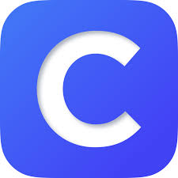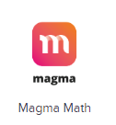

Log in to Clever- click on magma math

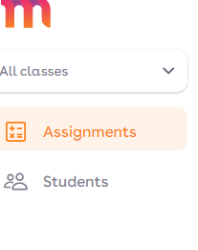Press the assignments tab

Press start

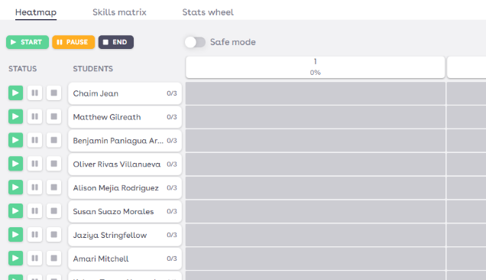

To see the questions click on a students name.

You will also be able to see their responses.

* Students **must show their work**, or they won’t be able to submit their answers.
* The answer box may not recognize all correct responses (e.g., if a student writes a complete sentence instead of just the answer). In these cases, teachers can manually correct the response.
* If **audio** is required, teachers must enable the **"Text to Speech"** feature in the teacher settings.

**How to Complete Magma Math Assessment(Student)**



Log in to Clever- click on magma math

Press the assignments tab

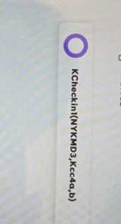

Students will click on the assignment - K check in

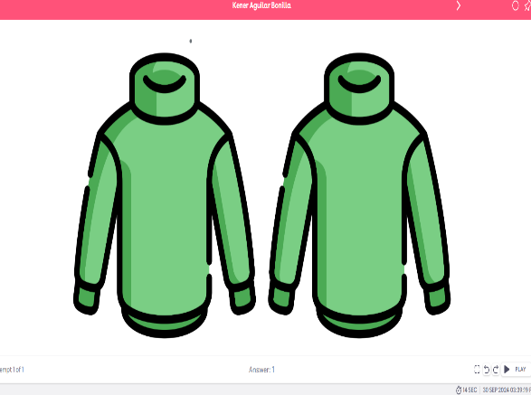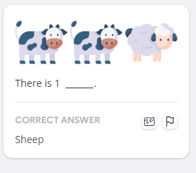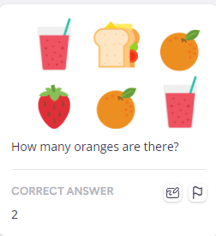

Students will answer all 3 questions. At the end they can press exit assignment.

This is what is will look like on the students end.

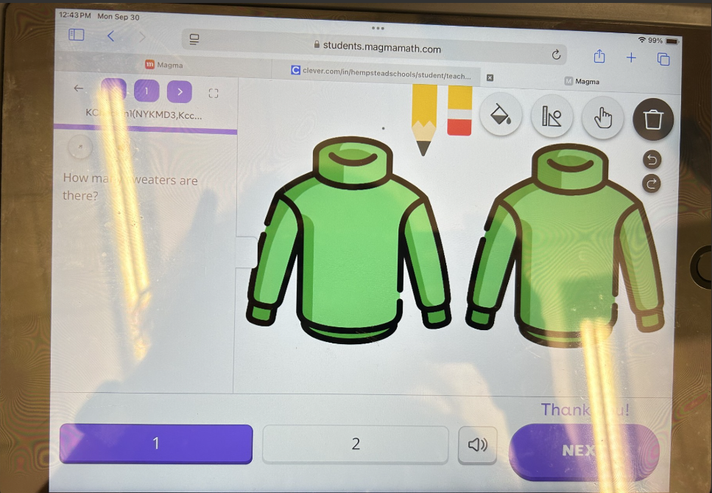

The pen to write/eraser

Audio to read

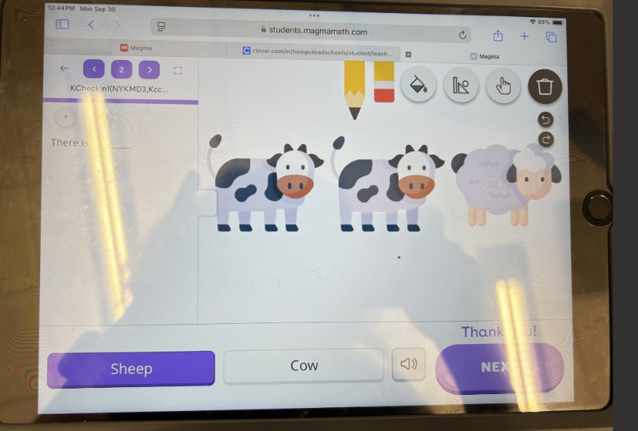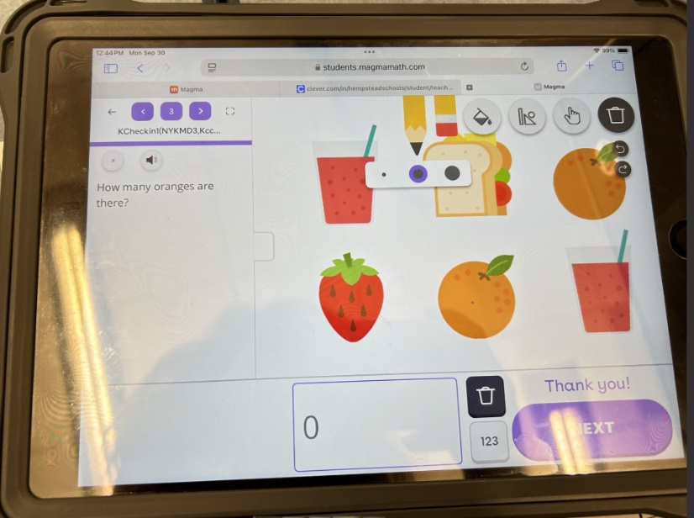

The pen to write/eraser

Click the 123 box to select the numbers students can choose from.